Short-term travel campaign guide

For Brokers with Individual Business

**The COVID recovery presents an opportunity to further build loyalty and trust**

Pre-COVID, only 32% of international travelers purchased international health insurance. But the uptake on international health insurance is projected to rise at least 130% in the next two years as travelers begin to take international trips again.

Our research shows that prior to the pandemic, **43%** of travelers did not make sure that they had the proper medical coverage for traveling abroad. And **16%** of those assumed that their domestic medical plan would cover them. What's more, **65%** are now more concerned about getting sick while traveling abroad and **74%** said they are more likely to buy coverage for future trips.1 ***This signals an opportunity to educate consumers on how to properly prepare for international travel.***

The content included in this guide will enable you to highlight the importance of international health insurance in a variety of ways--emails, social posts, and messaging to help you sell GeoBlue plans. ***Simply copy/paste the content provided in this guide*** or if you have questions on how to make the content relevant to your local market, contact Partner Program at [partnerprogram@geo-blue.com](mailto:partnerprogram@geo-blue.com).

**Peak season for short-term international travel**

The short-term peak travel season typically occurs during spring and summer vacation seasons—March through June, with a second smaller spike between July and August. This is the optimal time to promote GeoBlue short-term international travel medical plans.

With vaccines becoming more readily available, global travel will begin to rebound. There is increasing interest in exploring international destinations compared to earlier in the pandemic. Two-thirds of Americans continue to engage in some type of travel planning, from making reservations to researching travel destinations to simply daydreaming of a vacation, with beach vacations, iconic cities, and Europe topping the list of sought-after destinations.2

**Suggestions and guidelines for visual images**

* Recognizable international locations
* You may choose to show individuals and families wearing masks in public open spaces. You can also choose images that don’t show the face
* Refrain from showing extreme sports such as rock climbing or bungee jumping since GeoBlue plans have limitations associated with these types of activities**.**

**Incorporating the GeoBlue brand into your marketing efforts**

To maintain a cohesive brand experience for our partners, providers, prospects and members, it is important that our partner agents adhere to the required guidelines for proper use of our name, brand, logos symbols and marks. You can find these requirements on page 11 of the [Agent Guideline Manual](https://geoblue.sitefinity.cloud/docs/librariesprovider3/geoblue_emaildocs/individualsales_documents/brokerdocuments/2020/mar2020/geoblue_broker_onboarding_manual_fnl_021420.pdf?Status=Master&sfvrsn=9cb7a5f3_2) or email Partner Program at [partnerprogram@geo-blue.com](mailto:partnerprogram@geo-blue.com) with questions.

*Source:*

*1. GeoBlue research, Beneson Strategy Group, December 2020*

*2. Destination Analysts, Update on American Travel in the Period of Coronavirus – week of January 25.*

**Disclosure**

Please use this disclosure whenever you mention GeoBlue in your communications.

*GeoBlue is the trade name of Worldwide Insurance Services, LLC (Worldwide Services Insurance Agency, LLC in California and New York), an independent licensee of the Blue Cross and Blue Shield Association. GeoBlue is the administrator of coverage provided under insurance policies issued by 4 Ever Life International Limited, Bermuda, an independent licensee of the Blue Cross Blue Shield Association.*

If Global TeleMD™ (telemedicine services) is mentioned, add this disclosure:

*Telemedicine services are provided by Teladoc Health, directly to members. GeoBlue assumes no liability and accepts no responsibility for information provided by Teladoc Health and the performance of the services by Teladoc Health. Support and information provided through this service does not confirm that any related treatment or additional support is covered under a member’s health plan. This service is not intended to be used for emergency or urgent treatment medical questions.*

**How to track your sales**

Every sale of a GeoBlue product is tracked through your Agent ID number. This number connects you with your sale so that you get credit for every transaction. You also have a personal URL that you can share with your customers so sales are tied back to you. We included placeholders in the provided campaign content for you to insert your personal URL so you are credited for any sales generated by your marketing efforts.

If you cannot find or have questions on your personal URL, contact [partnerprogam@geo-blue.com](mailto:partnerprogam@geo-blue.com).

**Not currently an appointed GeoBlue broker/agent?**

Sign up on the Agent Hub to sell GeoBlue:

**NOTE TO PLANS:**

**INSERT YOUR PLAN-SPECIFIC AGENT HUB URL IN THE SPACE ABOVE. IF YOU DON’T KNOW IT, CONTACT** [partnerprogam@geo-blue.com](mailto:partnerprogam@geo-blue.com).

**PLEASE REMOVE THIS NOTE BEFORE RELEASING THIS DOCUMENT**

### General content messaging for member newsletters, blogs, and other communications

**Headline**

Getting prepared to explore the world again

**Subhead**

Steps you can take now to feel safe and secure when traveling internationally

**Copy**

While the past year prevented many from traveling, the desire to take that previously scheduled trip or long-planned vacation hasn’t subsided. With all the cheap flights and vacation deals, you may be thinking that 2021 is finally the right time take that trip of your dreams.

Dreaming is one thing. Feeling ready to book a trip is another. Here are some steps you can take right now to plan a successful international journey.

**Do your research**. Refer to agencies such as the [Centers for Disease Control](http://www.cdc.gov) and [U.S. Department of State](https://travel.state.gov/content/travel/en/traveladvisories/ea/covid-19-information.html) for the latest guidelines and travel advisories so you can choose your destination wisely, and better understand the requirements for re-entering the U.S.

**Make sure you are covered**. Purchasing a short-term international health insurance plan is one of smartest things you can do to protect both your health and your finances. You may be thinking, “Won’t the health insurance plan I already have be sufficient if I get sick or injured in another country?” The answer is that it probably does not have the right kind of protection you need when you travel outside the U.S.

There are health insurance plans that are specifically designed for international travel. Plans like **GeoBlue**® [link to your personal URL] have no deductible and cover important needs like medically necessary evacuations which can cost you thousands of dollars out of pocket and are typically not covered by your U.S. medical plan.

GeoBlue also has a flexible cancellation policy, covers medically necessary COVID-19 testing and treatment, and includes Global TeleMD™ telemedicine services for contactless access to care in case you need it.

**Get familiar with your destination**. A plan like **GeoBlue** [link to your personal URL] provides a mobile app that you can download before you travel, so you can locate quality providers, view destination profiles, get the latest on any regional safety concerns, and so much more.

No matter where you plan to travel, a little preparation can go a long way to getting your international journey off on the right foot.

### Social content messaging for short-term travel

**Note:** You can link the posts to your personal URL on [www.geobluetravelinsurance.com](http://www.geobluetravelinsurance.com) by inserting your personal link ID in the green section noted below. By doing so, we will be able to track your sales from this social media campaign. Contact the GeoBlue Partner Program ([partnerprogram@geo-blue.com](mailto:partnerprogram@geo-blue.com)) with any questions about your personal URL or your personal link ID.

**GENERAL INFORMATION POSTS**

|  |
| --- |
| **Post 1** |
| **POST:** If an international vacation is in your future, where will you go first? Be sure to check out the [**cdc.gov**](http://www.cdc.gov) and [**travel.state.gov**](http://www.travel.state.gov) for the latest travel advisories and requirements to reenter the U.S. Make sure you have an international health insurance plan that has a flexible cancellation policy, like #GeoBlue, so you’re covered for medically necessary COVID-19 testing and treatment, and evacuation if medically necessary. For more information on international travel medical plans, visit*:*  [INSERT ONE OF THE LINK OPTIONS BELOW]  **HASHTAGS:**   #geoblue #covid19 #internationalmedicalinsurance #vacationtravel #travelmedical #insurance #digitalnomad #internationaltravel  **LINK OPTIONS:**  **Link to your personal URL with link ID**  [*https://www.geobluetravelinsurance.com/?link_id=PERSONAL_LINK_ID&personalized=y&header=y&utm_source=blpltkbroker202101&utm_medium=social&utm_campaign=blplsocial*](https://www.geobluetravelinsurance.com/?link_id=PERSONAL_LINK_ID&personalized=y&header=y&utm_source=blpltkbroker202101&utm_medium=social&utm_campaign=blplsocial)  **Link to the general GeoBlue travel insurance site with no personalization and no link ID. *This link is not able to track your sales.***  [*https://www.geobluetravelinsurance.com?utm_source=blpltkbroker202101&utm_medium=social&utm_campaign=blplsocial*](https://www.geobluetravelinsurance.com?utm_source=blpltkbroker202101&utm_medium=social&utm_campaign=blplsocial) |
| **VISUAL:**  *Proposed content for visual such as image suggestions, placement, campaign considerations.*  (logos & disclaimer)  *(visual suggestions – couple or family in internationally-recognized vacation destination; recommend images with masks)*  BEFORE YOU GO  International pre-travel planning considerations   * Check [**cdc.gov**](http://www.cdc.gov) and [**travel.state.gov**](http://www.travel.state.gov) for the latest travel advisories and requirements by country * Check your international insurance plan’s COVID-19 coverage and cancellation policy   *If GeoBlue logo is used, the graphic will require the following disclaimer:*  *GeoBlue is the trade name of Worldwide Insurance Services, LLC (Worldwide Services Insurance Agency, LLC in California and New York), an independent licensee of the Blue Cross and Blue Shield Association.* |
| IMAGE SIZE: 1200x630 – FB, LI, TW 1080x1080 - IG |

|  |
| --- |
| **Post 2** |
| **POST:** What would happen if you got sick or injured while traveling abroad? The truth is your domestic medical plan may not have the right coverage, leaving you vulnerable to paying thousands of dollars in out-of-pocket medical costs. You can cover the gaps with a GeoBlue short-term international insurance plan if you get sick, injured, or have a medical emergency while traveling outside the U.S. Plans include comprehensive coverage for medical necessary evacuation, medical necessary COVID-19 testing and treatment, 24/7 support, telemedicine services, and more. For more information on international travel medical plans, visit:  [INSERT ONE OF THE LINK OPTIONS BELOW]  **HASHTAGS:**  #geoblue #covid19 #internationalmedicalinsurance #vacationtravel #travelmedical #insurance #digitalnomad #internationaltravel  **LINK OPTIONS:**  **Link to your personal URL with link ID**  [*https://www.geobluetravelinsurance.com/?link_id=PERSONAL_LINK_ID&personalized=y&header=y&utm_source=blpltkbroker202102&utm_medium=social&utm_campaign=blplsocial*](https://www.geobluetravelinsurance.com/?link_id=PERSONAL_LINK_ID&personalized=y&header=y&utm_source=blpltkbroker202102&utm_medium=social&utm_campaign=blplsocial)  **Link to the general GeoBlue travel insurance site with no personalization and no link ID. *This link is not able to track your sales.***  [*https://www.geobluetravelinsurance.com?utm_source=blpltkbroker202102&utm_medium=social&utm_campaign=blplsocial*](https://www.geobluetravelinsurance.com?utm_source=blpltkbroker202102&utm_medium=social&utm_campaign=blplsocial) |
| **VISUAL:**  *Proposed content for visual such as image suggestions, placement, campaign considerations.*  (logo/s & disclaimer)  *(visual – map graphic with hop from U.S. to international location/Europe)*  Planning an international trip?  Be sure you are  Covered here. Covered there.  *If GeoBlue logo is used, the graphic will require the following disclaimer:*  *GeoBlue is the trade name of Worldwide Insurance Services, LLC (Worldwide Services Insurance Agency, LLC in California and New York), an independent licensee of the Blue Cross and Blue Shield Association.* |
| IMAGE SIZE: 1200x630 – FB, LI, TW 1080x1080 - IG |

### Digital banner ads for short-term travel

GeoBlue provides you with a variety of online banner ads to support your targeted marketing programs. These banner ads were designed for you to use on websites, blogs, online newsletters, etc. to increase product awareness and sales by increasing traffic to your web page. You will want to include your personalized link which can be obtained on the home page of Agent Hub or by emailing [partnerprogram@geo-blue.com](mailto:partnerprogram@geo-blue.com).

**To Access:**

1. Visit [www.geobluetravelinsurance.com](http://www.geobluetravelinsurance.com)
2. Click on “Agents” in the upper right-hand corner
3. Log in using your username and password
4. Select "Marketing” at the bottom of the homepage and then select “Banner Ads”
5. From here, you can view and download available banner ads to use across your digital sites.

**BANNER ADS**

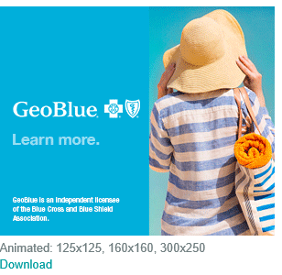

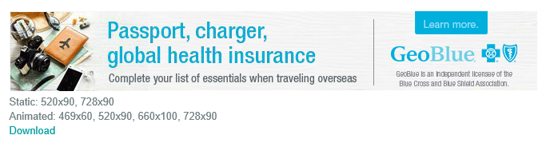

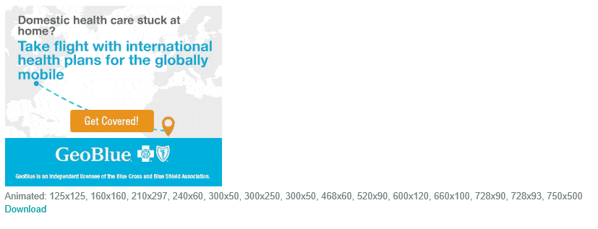

*GeoBlue is the trade name of Worldwide Insurance Services, LLC (Worldwide Services Insurance Agency, LLC in California and New York), an independent licensee of the Blue Cross and Blue Shield Association. GeoBlue is the administrator of coverage provided under insurance policies issued by 4 Ever Life International Limited, Bermuda, an independent licensee of the Blue Cross Blue Shield Association.*